show user;

grant connect, resource to tanujadb;

alter session set current_schema=tanujadb;

NUMERICFUNCTIONS

SELECT ceil(24.567) FROM dual;

O/P: 25

SELECT floor(24.567) FROM dual;

O/P: 24

SELECT round(24.567) FROM dual;

O/P: 25

SELECT round(24.567,1) FROM dual;

O/P: 24.6

SELECT round(24.567,-1) FROM dual;

O/P: 20

SELECT trunc(24.567,1) FROM dual;

O/P: 24.5

SELECT power(5,2) FROM dual;

O/P: 25

SELECT sqrt(64) FROM dual;

O/P: 8

SELECT mod(5,2) FROM dual;

O/P: 1

SELECT ceil(sal) FROM emp;

O/P:

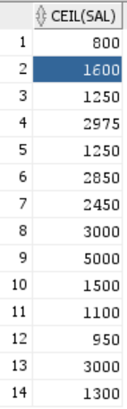

DATEFUNCTIONS

SELECT ename,lpad('*',length(ename),'*') as e FROM emp;

O/P:

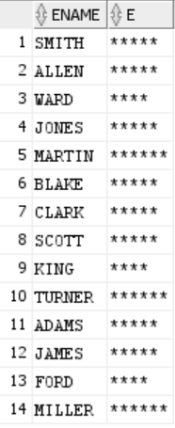

SELECT sysdate FROM dual;

O/P: 06-12-21

SELECT current_date FROM dual;

O/P: 06-12-21

SELECT sysdate+7 FROM dual;

O/P: 13-12-21

SELECT sysdate-7 FROM dual;

O/P: 29-11-21

SELECT ADD_MONTHS(sysdate,3) FROM dual;

O/P: 06-03-22

SELECT MONTHS_BETWEEN(sysdate,'20-MAY-2014') FROM dual;

O/P: 90.56370445041816009557945041816009557945

SELECT LAST_DAY(sysdate) FROM dual;

O/P: 31-12-21

SELECT NEXT_DAY(sysdate,3) FROM dual;

O/P: 07-12-21

SELECT NEXT_DAY(sysdate,1) FROM dual;

O/P: 12-12-21

SELECT NEXT_DAY(sysdate,2) FROM dual;

O/P: 13-12-21

SELECT NEXT_DAY(sysdate,7) FROM dual;

O/P: 11-12-21

SELECT NEXT_DAY(sysdate,'friday') FROM dual;

O/P: 10-12-21

SELECT NEXT_DAY(sysdate,'wednesday') FROM dual;

O/P: 08-12-21

SELECT NEXT_DAY(sysdate+30,'wednesday') FROM dual;

O/P: 12-01-22

SELECT EXTRACT(year FROM sysdate) FROM dual;

O/P: 2021

SELECT EXTRACT(month FROM sysdate) FROM dual;

O/P: 12

SELECT EXTRACT(day FROM sysdate) FROM dual;

O/P: 6

CONVERSIONFUNCTIONS

SELECT TO_CHAR(2560,'$9,999.0') FROM dual;

O/P: $2,560.0

SELECT TO_CHAR(2560,'$0,00,000.00') FROM dual;

O/P: $0,02,560.00

SELECT TO_CHAR(sal,'$9,999.00') FROM emp;

O/P:

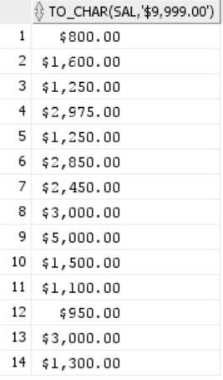

SELECT TO_CHAR(sysdate,'DD MONTH YYYY') FROM dual;

O/P: 06 DECEMBER 2021

SELECT TO_CHAR(sysdate,'DDth MONTH YY') FROM dual;

O/P: 06TH DECEMBER 21

SELECT TO_CHAR(sysdate,'DDspth MONTH YY') FROM dual;

O/P: SIXTH DECEMBER 21

SELECT TO_DATE ('May 22,2014','Month DD, YYYY') FROM dual;

O/P: 22-05-14

SELECT TO_CHAR(sysdate,'D') FROM dual;

O/P: 2

SELECT TO_CHAR(sysdate,'d') FROM dual;

O/P: 2

SELECT TO_CHAR(sysdate,'DD') FROM dual;

O/P: 06

CHARACTERFUNCTIONS

SELECT lower('Oracle') FROM dual;

O/P: oracle

SELECT upper('Oracle') FROM dual;

O/P: ORACLE

SELECT instr('Oracle','a') FROM dual;

O/P: 3

SELECT concat('Oracle','for') FROM dual;

O/P: Oraclefor

SELECT concat(concat('Oracle',' for'),' developers') FROM dual;

O/P: Oracle for developers

SELECT 'Oracle '||'for '||'Developers' FROM dual;

O/P: Oracle for Developers

SELECT substr('Oracle',2) FROM dual;

O/P: racle

SELECT substr('Oracle',2,2) FROM dual;

O/P: ra

SELECT length('Oracle for Developers') FROM dual;

O/P: 21

SELECT ltrim(' Oracle for Developers') FROM dual;

O/P: Oracle for Developers

SELECT rtrim(' Oracle for Developers ') FROM dual;

O/P: Oracle for Developers

SELECT lpad('Oracle',10,'*') FROM dual;

O/P: ****Oracle

SELECT rpad('Oracle',10,'*') FROM dual;

O/P: Oracle****

MISCELLANEOUSFUNCTIONS

SELECT mgr FROM emp;

O/P:

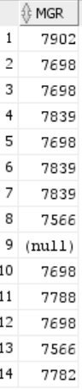

SELECT nvl(mgr,0) FROM emp;

O/P:

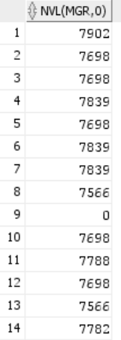

SELECT NVL2(mgr,0,1) FROM emp;

O/P:

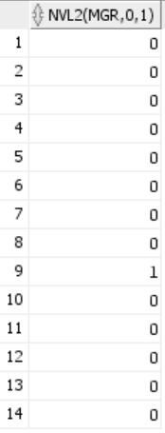

SELECT NULLIF(deptno,10) FROM emp;

O/P:

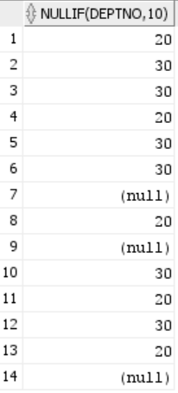

SELECT ename,DECODE (deptno, 10, 'Accounting', 20, 'Research', 30, 'Sales',

'Unknown') AS department FROM emp;

O/P:

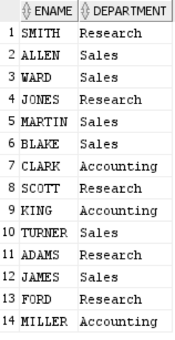

SELECT ename,CASE deptno WHEN 10 THEN 'Accounting' WHEN 20 THEN 'Research' WHEN 30

THEN 'Sales' ELSE 'Unknown' END AS department FROM emp;

O/P:

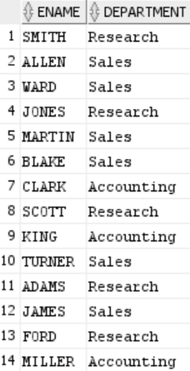

SELECT sal, CASE WHEN sal < 2000 THEN 'category 1' WHEN sal < 3000 THEN 'category 2'

WHEN sal < 4000 THEN 'category 3' ELSE 'category 4' end FROM emp;

O/P:

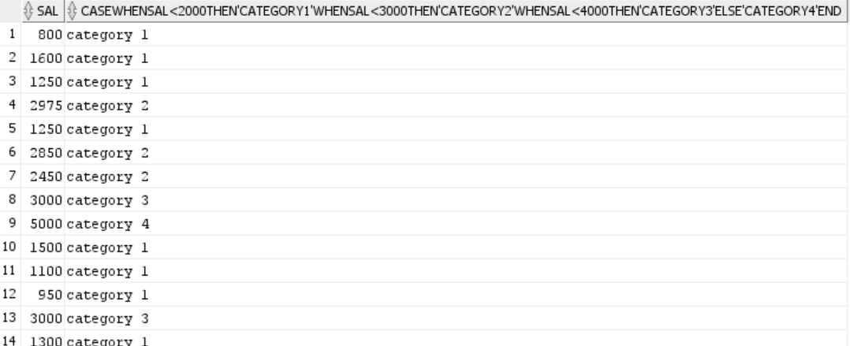

GROUPFUNCTIONS

SELECT floor((sysdate-hiredate)/365) FROM emp;

O/P:

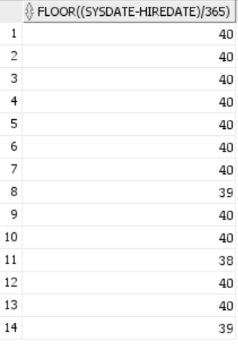

SELECT (sysdate-hiredate)/365 FROM emp;

O/P:

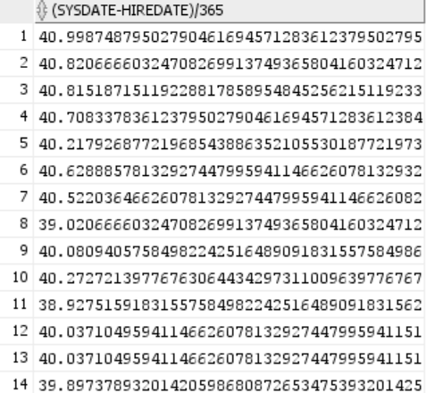

SELECT sal as salary FROM emp;

O/P:

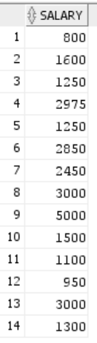

SELECT sum(sal) as TotalSalary FROM emp;

O/P: 29025

SELECT min(sal) FROM emp;

O/P: 800

SELECT max(sal) FROM emp;

O/P: 5000

SELECT avg(sal) FROM emp;

O/P: 2073.214285714285714285714285714285714286

SELECT sum(sal)*12 as TotalSalary FROM emp;

O/P: 348300

SELECT count(*) FROM emp;

O/P: 14

SELECT count(mgr) FROM emp;

O/P: 13

SELECT count(*) FROM emp;

O/P: 14

SELECT count(deptno) FROM emp;

O/P: 14

SELECT count(*) FROM emp GROUP BY deptno;

O/P:

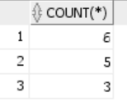

SELECT count(*), deptno FROM emp GROUP BY deptno;

O/P:

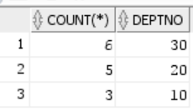

SELECT count(*), deptno FROM emp GROUP BY deptno ORDER BY 2;

O/P:

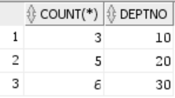

SELECT count(*), deptno FROM emp GROUP BY deptno,sal ORDER BY 2;

O/P:

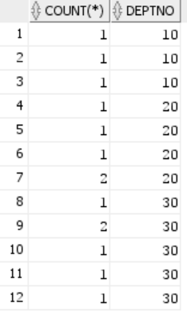

SELECT count(*), deptno FROM emp GROUP BY deptno HAVING count(*)>2 ORDER BY 2;

O/P:

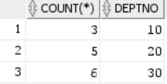

SELECT count(*), job FROM emp GROUP BY job HAVING min(sal)>1500;

O/P:

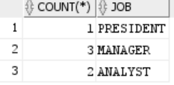

DEMO

set linesize 300 column sal format A4

SELECT empno,ename FROM emp WHERE sal>3000;

SELECT empno,ename,sal FROM emp WHERE sal>3000;

column sal format A30;

SELECT empno,ename FROM emp WHERE sal>3000;

SELECT empno as Employeenumber, ename "Employee Name" FROM emp WHERE sal>3000;

column "Employee Name" format A30

SELECT * from emp;

SELECT ename FROM emp WHERE ename like '%S';

SELECT ename FROM emp WHERE ename like 'k%';

SELECT ename FROM emp WHERE ename like 'K%';

SELECT ename FROM emp WHERE ename like 'SMI_H';

SELECT ename FROM emp WHERE ename like 'ALL\_N' escape '\';

SELECT job FROM emp;

SELECT DISTINCT job FROM emp;

SELECT ename,sal as salary FROM emp;

SELECT ename,sal as salary FROM emp ORDER BY sal;

SELECT ename,sal as salary FROM emp ORDER BY sal desc;

SELECT ename,sal as salary FROM emp ORDER BY 2 desc;

SELECT floor((sysdate-hiredate)/365) FROM emp ORDER BY 1;

SELECT ename FROM emp ORDER BY 1;

SELECT ename,sal as salary FROM emp ORDER BY 2 desc;

SELECT ename,sal as salary FROM emp ORDER BY 2 desc,ename desc;

SELECT sal+comm FROM emp;

SELECT sal||' '|| comm FROM emp;